**Project 7: Send Mail through a bot**

**Aim:** To send mail to the requested Mail ID with attachment of a file located in the System and Date.

**Solution Definition:**

1. Convert System Date to string and store it in string variable.
2. Get your EMAIL Server Host, Mail ID from which Bot would send and 2FA associated password of that MAIL ID.
3. Get To mail address and Attachment file path as Inputs.

**Procedure to Create the Bot:**

* Create a Credential to store your MAIL address and 2FA password. Now add that credential to a Locker Variable.
* Create a Bot.

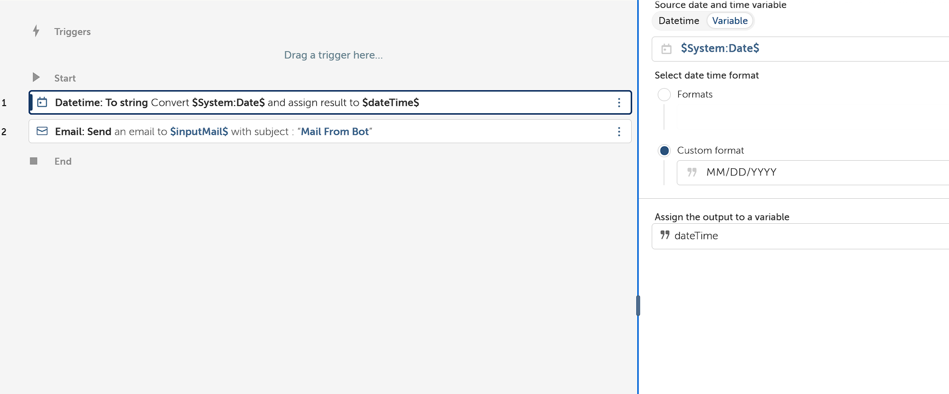

* Using datetime: To String Action, Convert System date (In-built Variable) to String and store it in String Variable.

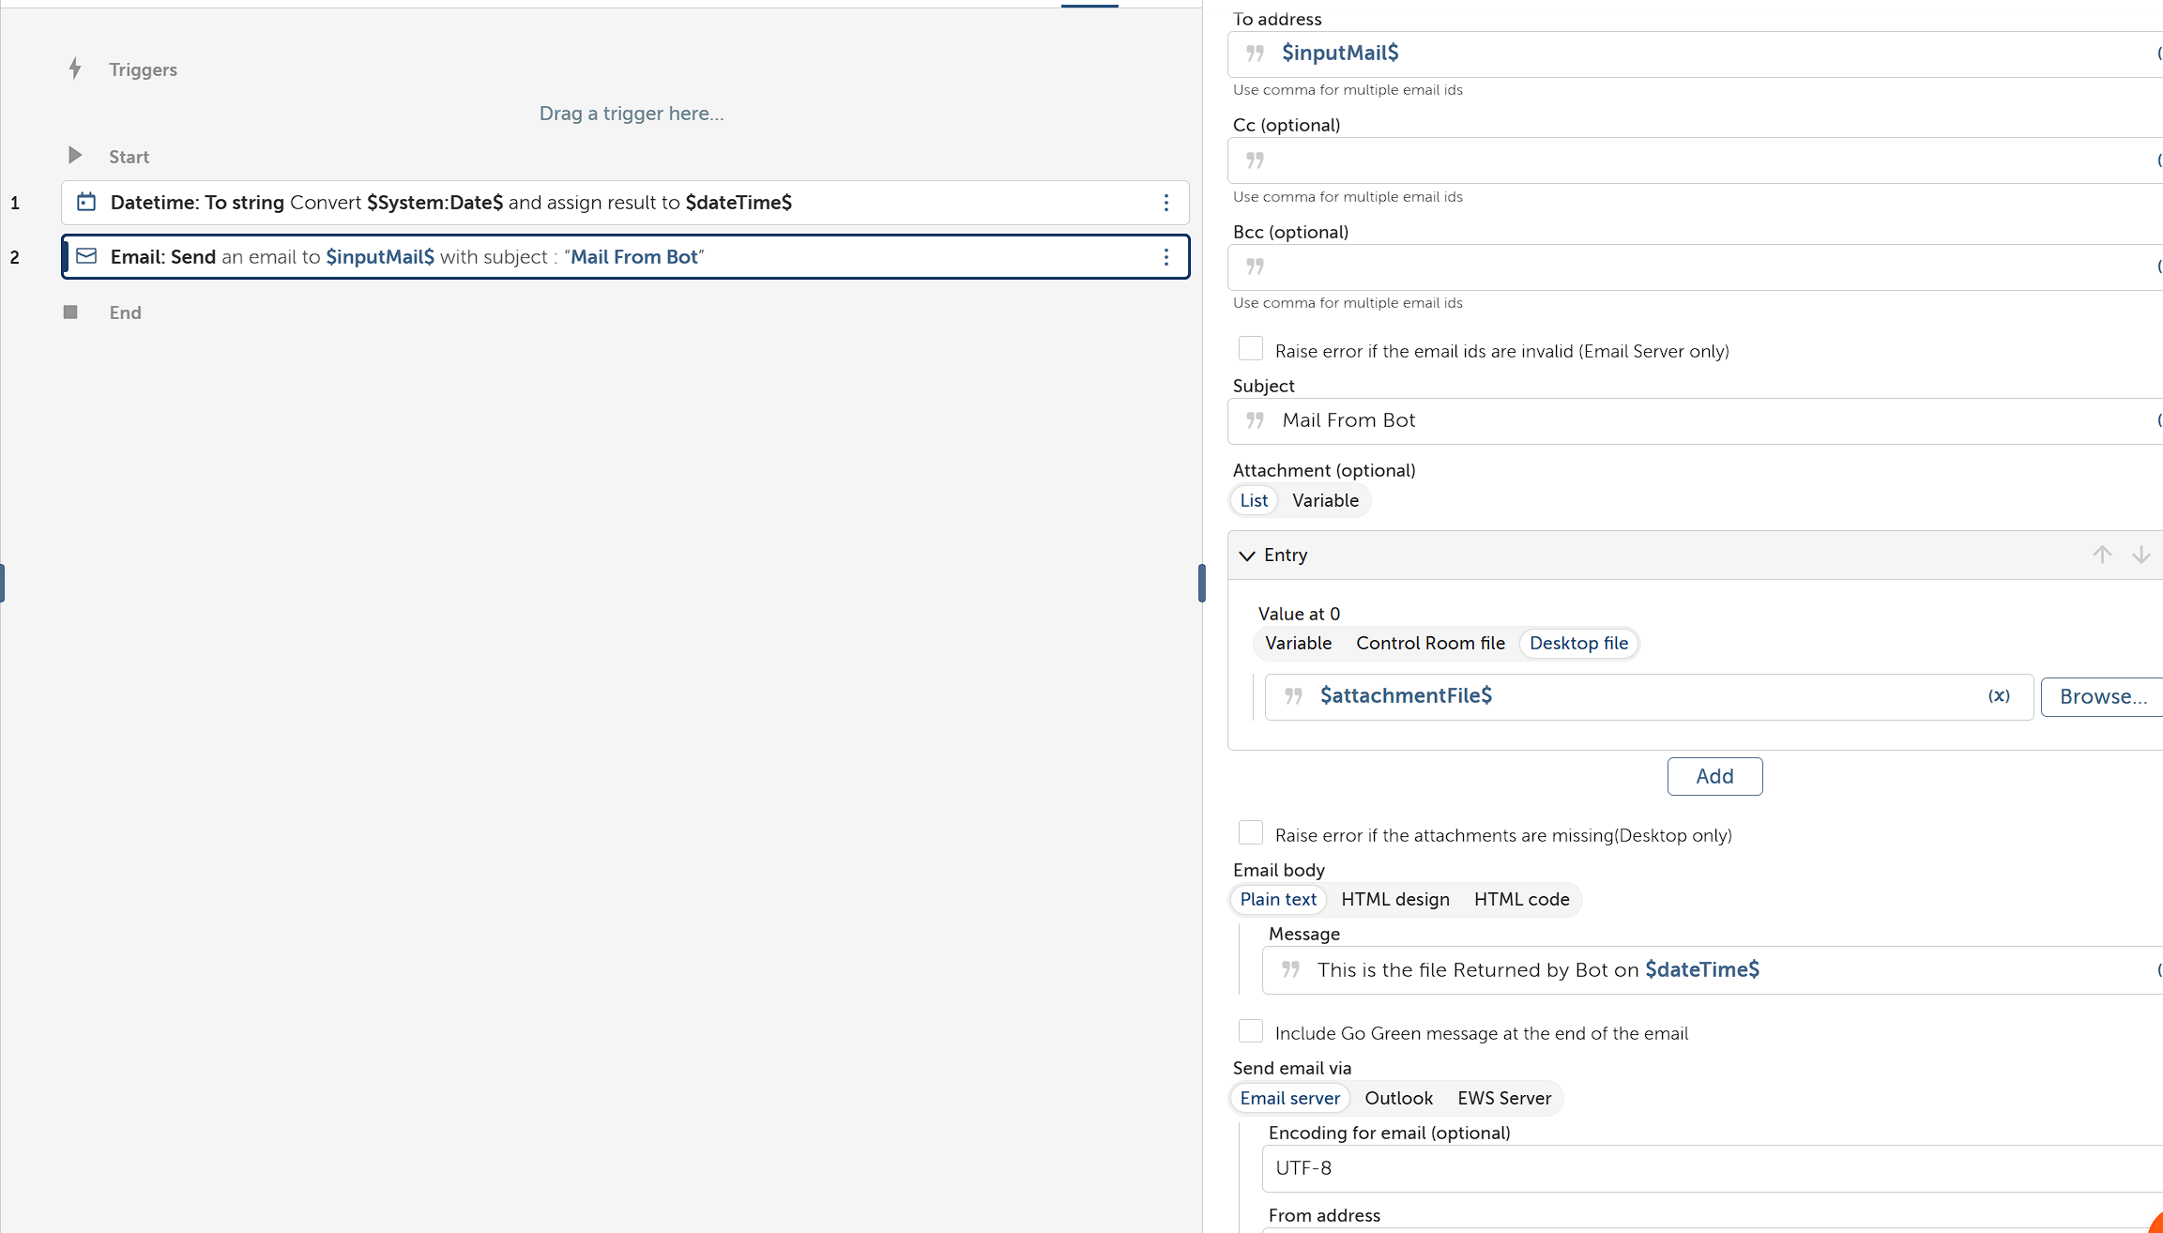

* Add Email: Send action to According Provide input To the Fields.

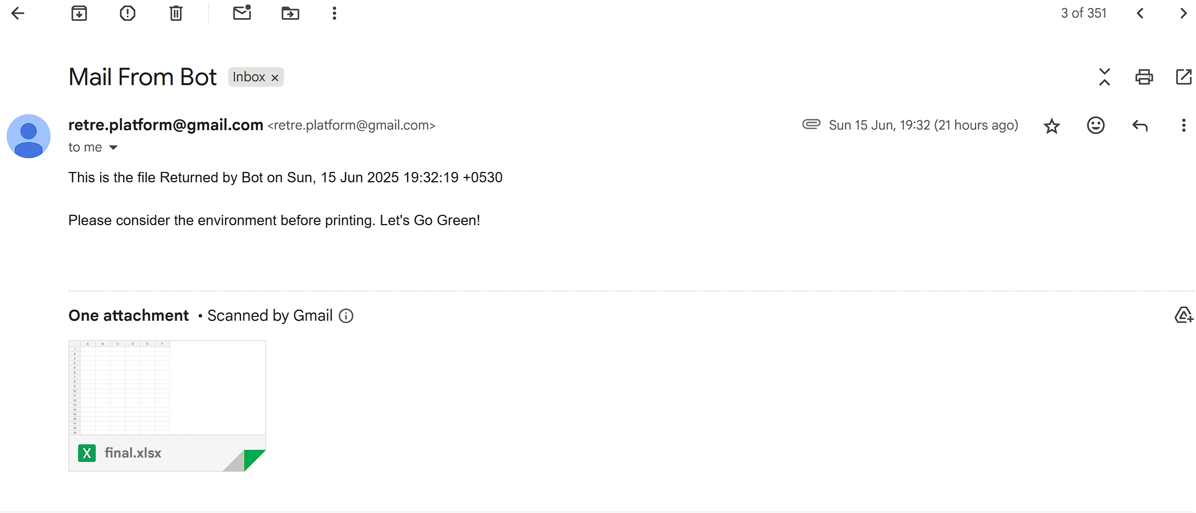

* Run the Bot and now Receiver would have received the mail.